Assignment - 13
Task – 13
Description: Remove Repetition
Task: Provide AI with the following redundant code and ask it to refactor
Python Code
def calculate_area(shape, x, y=0):
if shape == "rectangle":
return x * y
elif shape == "square":
return x * x
elif shape == "circle":
return 3.14 * x * x

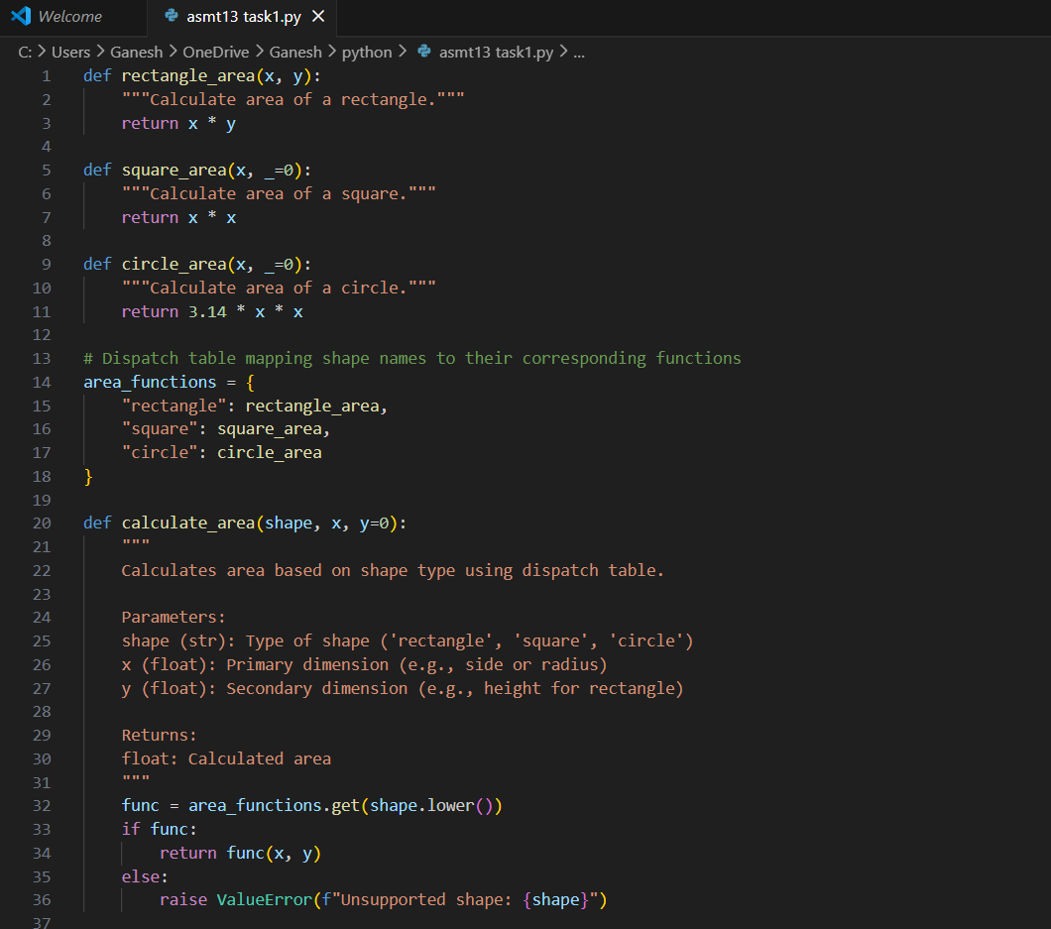
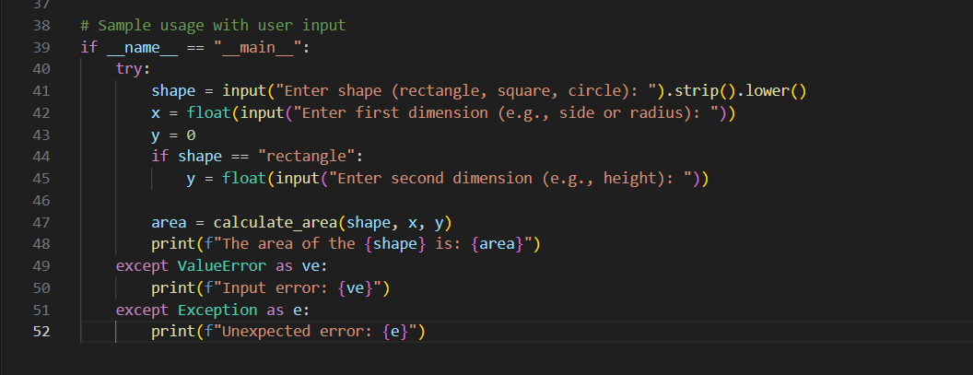

Practical Output:

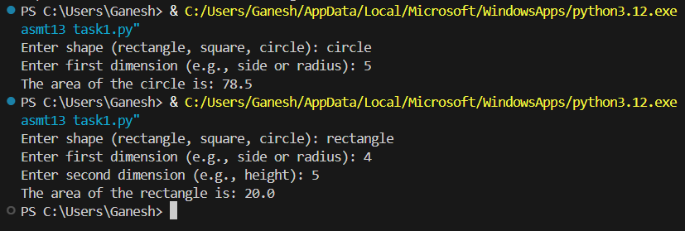

Task – 2
Description: Error Handling in Legacy Code
Task: Legacy function without proper error handling
Python Code
def read_file(filename):
f = open(filename, "r")
data = f.read()
f.close()
return data
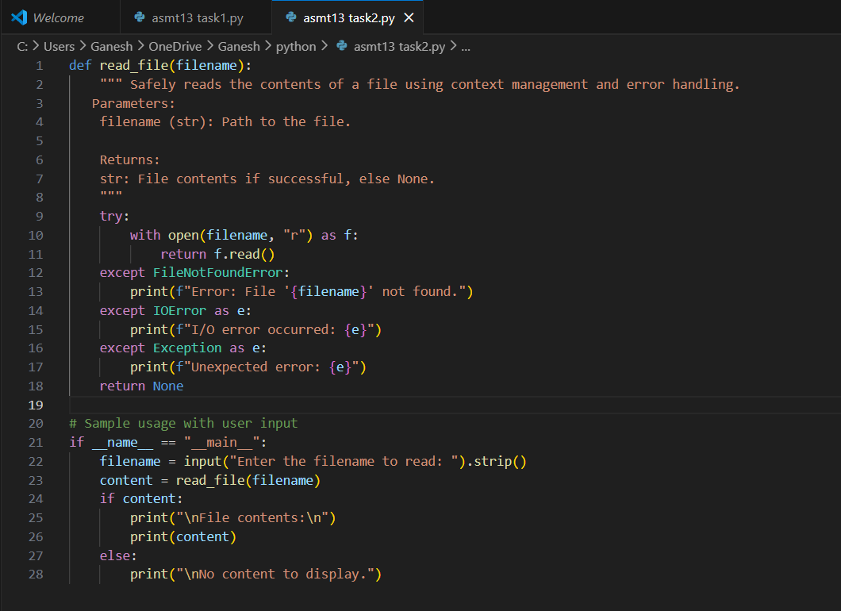

Practical Output:

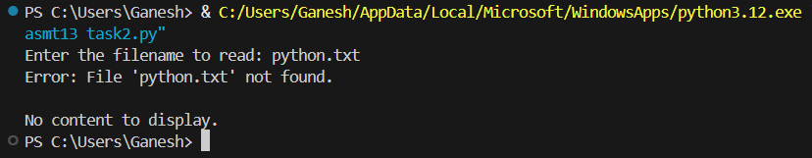

Task - 3
Description: Complex Refactoring
Task: Provide this legacy class to AI for readability and modularity improvements:
Python Code
class Student:
def __init__(self, n, a, m1, m2, m3):
self.n = n
self.a = a
self.m1 = m1
self.m2 = m2
self.m3 = m3
def details(self):
print("Name:", self.n, "Age:", self.a)
def total(self):
return self.m1+self.m2+self.m3

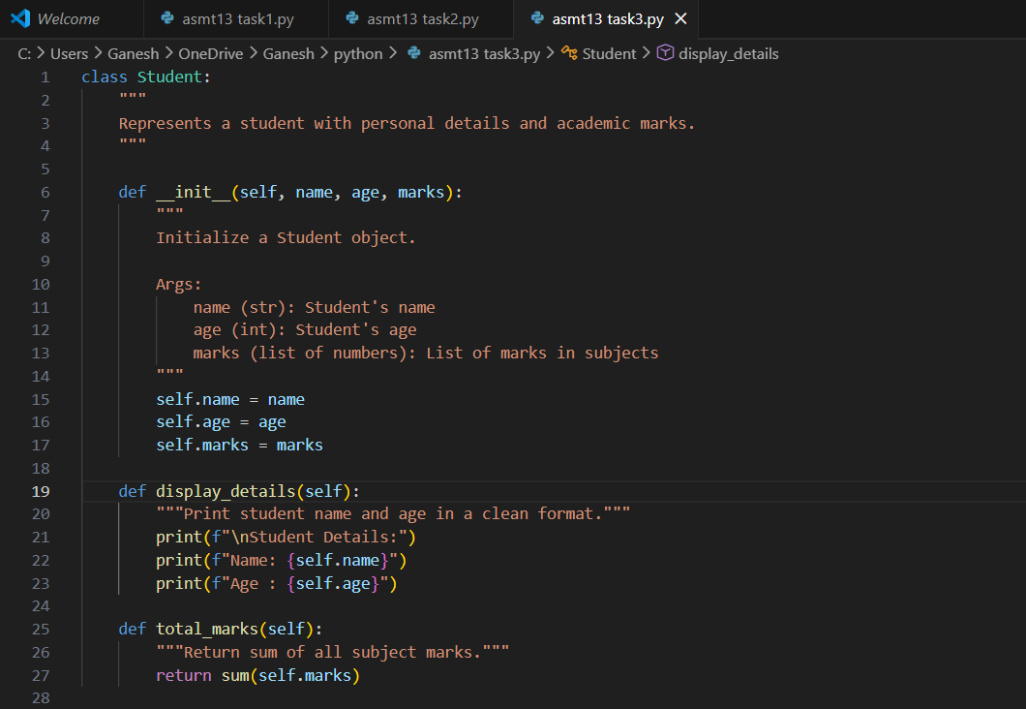
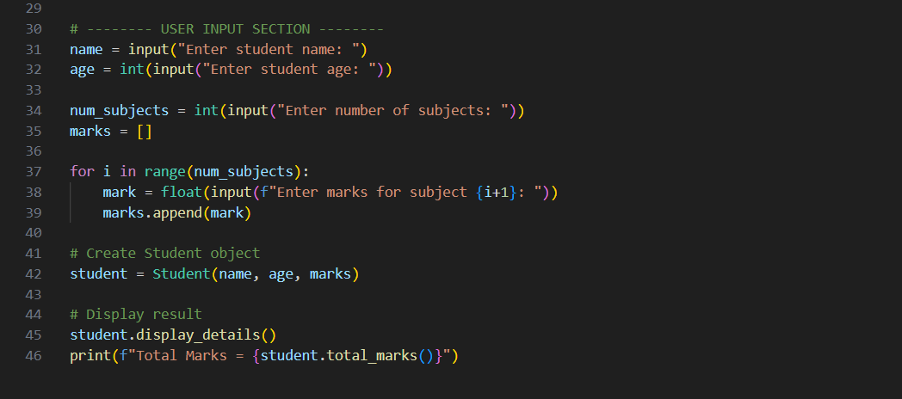

Practical Output:

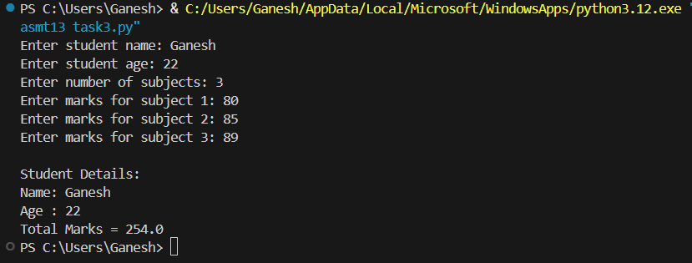

Task – 4
Description: Inefficient Loop Refactoring
Task: Refactor this inefficient loop with AI help
Python Code
nums = [1,2,3,4,5,6,7,8,9,10]
squares = []
for i in nums:
squares.append(i * i)

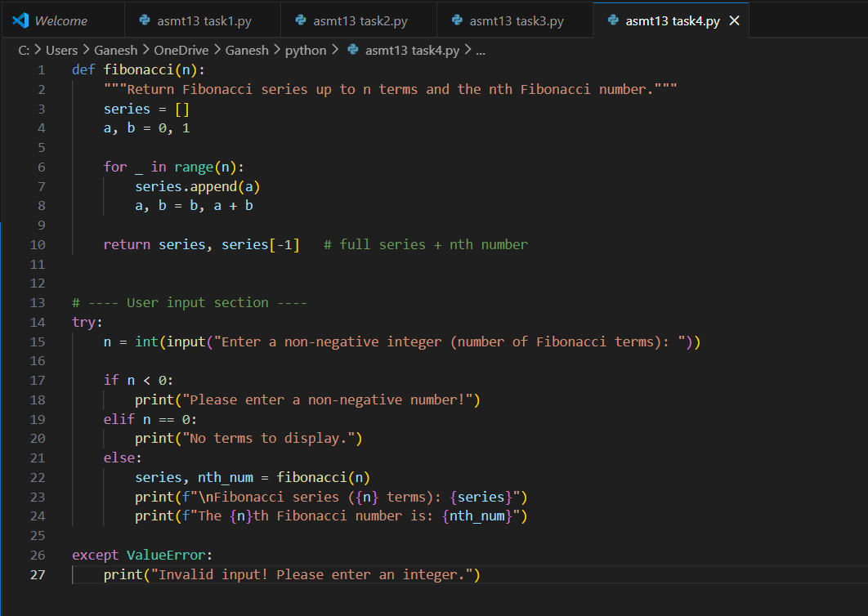
Practical Output:

